Create ci pipeline that will deploy and configure these VMs using terraform and ansible according following requirements

- Deploy 2 virtual machines using terraform.
first vm on Amazon linux, hostname: c8.local
second vm on ubuntu 21.04, hostname: u21.local

- As a result of terraform execution, dynamically create inventory for ansible
c8.local should be in the frontend group
u21.local should be in the backend group

- Create ansible playbook for c8.local and u21.local

for linux OS playbook should apply the following changes
- selinux: disable
- firewalld: disable

for frontend playbook group should install and configure nginx
- nginx configuration should do proxying from port 80 on port 19999 to the
- backend group

for the backend group, the playbook must install the Netdata application from the
- official repositories and run it on port 19999.

Task Title
Automated Infrastructure Provisioning and Monitoring using Terraform + Ansible + Jenkins
Objective
To design and implement a CI/CD pipeline that:
- Provisions two EC2 instances using Terraform
  - Frontend (Amazon Linux – Nginx reverse proxy)
  - Backend (Ubuntu – Netdata monitoring)
- Automatically configures servers using Ansible
- Deploys Netdata on backend and exposes it via:
  - Direct access on port 19999
  - Reverse proxy via Nginx on frontend
- Orchestrates everything using Jenkins Pipeline
- Achieves fully automated deployment from GitHub source code
Prerequisites
- AWS account with IAM access keys
- Jenkins server with:
  - Git
  - Terraform
sudo yum install -y yum-utils
sudo yum-config-manager --add-repo https://rpm.releases.hashicorp.com/AmazonLinux/hashicorp.repo
sudo yum -y install terraform
  - Ansible
sudo yum install ansible -y
- In Jenkins GUI
  - Install SSH Agent Plugin and AWS credentials
  - Add Credentials of aws credentials and also ssh username with private key (id = ec2-user and paste the pem key)
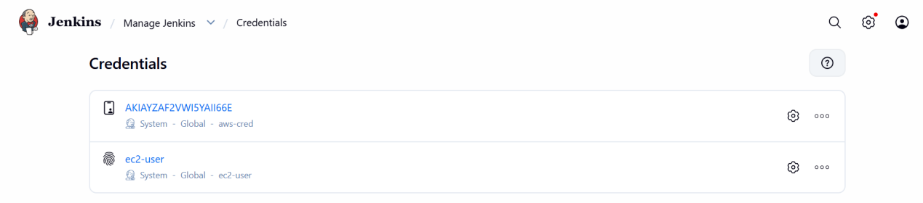

- GitHub repository (public)
- Security Groups allowing:
  - SSH (22)
  - HTTP (80)
  - Netdata (19999)

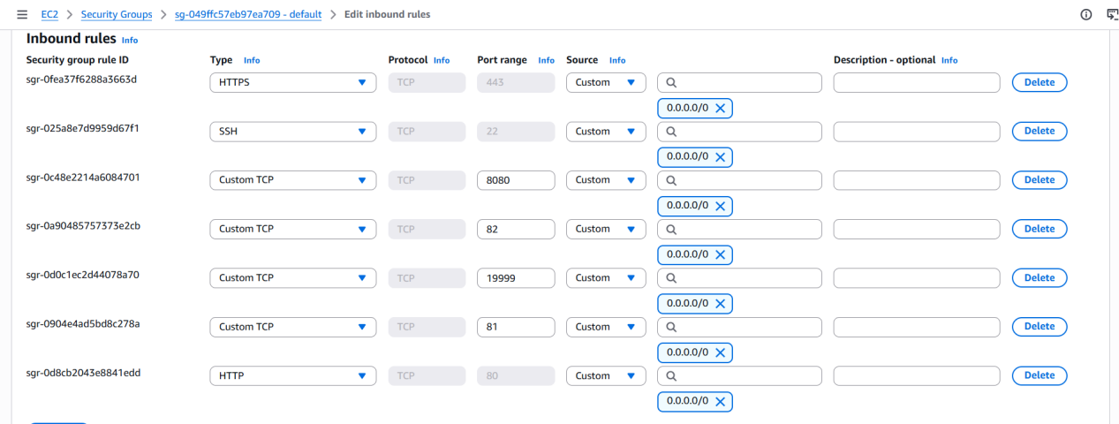

GitHub Repository Structure
ansible-challenge/
│
├── ansible/
│ ├── linux.yml
│ ├── backend.yml
│ └── frontend.yml
│
├── terraform/
│ ├── ec2..tf
│ └── inventory.tf
│
├── Jenkinsfile
└── README.md

Step-by-Step Implementation:
Step 1: Create GitHub Repository
- Repository name: ansible-challenge
- Visibility: Public
- Added README
- Pushed Terraform, Ansible, and Jenkinsfile

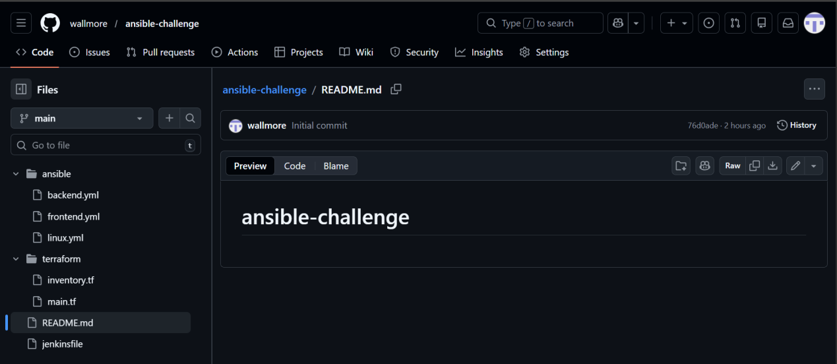

Step 2: Terraform – Infrastructure Provisioning
ec2.tf:
provider "aws" {
region = "us-east-1"
}
resource "aws_instance" "frontend" {
ami = "ami-0f3caa1cf4417e51b"
instance_type = "t3.micro"
key_name = "logical"
tags = {
Name = "c8.local"
}
}

resource "aws_instance" "backend" {
ami = "ami-0b6c6ebed2801a5cb"
instance_type = "t3.micro"
key_name = "logical"
tags = {
Name = "u21.local"
}
}
Step 3: Terraform – Dynamic Ansible Inventory
inventory.tf:
resource "local_file" "ansible_inventory" {
filename = "${path.module}/../ansible/inventory.ini"
content = <<EOF
[frontend]
c8.local ansible_host=${aws_instance.frontend.public_ip} ansible_user=ec2-user

[backend]
u21.local ansible_host=${aws_instance.backend.public_ip} ansible_user=ubuntu

EOF
}

Step 4: Ansible – Common Configuration
linux.yml
---
- name: Common Linux Configuration
hosts: all
become: yes

tasks:

- name: Disable SELinux immediately (RHEL-based only)
ansible.posix.selinux:
state: disabled
when: ansible_os_family == "RedHat"

- name: Disable SELinux permanently (RHEL-based only)
lineinfile:
path: /etc/selinux/config
regexp: '^SELINUX='
line: 'SELINUX=disabled'
when: ansible_os_family == "RedHat"

- name: Stop firewalld (if exists)
service:
name: firewalld
state: stopped
ignore_errors: yes

- name: Disable firewalld (if exists)
service:
name: firewalld
enabled: no
ignore_errors: yes

Step 5: Ansible – Backend (Netdata)
backend.yml :
---
- name: Install and Configure Netdata Backend
hosts: backend
become: yes

tasks:

- name: Install required packages (Ubuntu/Debian)
apt:
update_cache: yes
name:
- curl
state: present
when: ansible_os_family == "Debian"

- name: Install required packages (RHEL/Amazon)
yum:
name:
- curl
state: present
when: ansible_os_family == "RedHat"

# ✅ FIXED SECTION (No more bash process substitution)

- name: Download Netdata install script
get_url:
url: https://my-netdata.io/kickstart.sh
dest: /tmp/netdata-kickstart.sh
mode: '0755'
when: not ansible_facts.services['netdata.service'] is defined
ignore_errors: yes

- name: Install Netdata
command: bash /tmp/netdata-kickstart.sh --dont-wait
args:
creates: /usr/sbin/netdata

- name: Ensure Netdata binds to port 19999
lineinfile:
path: /etc/netdata/netdata.conf
regexp: '^\s*bind to ='
line: ' bind to = 0.0.0.0:19999'
notify: restart netdata
ignore_errors: yes

- name: Enable and start Netdata
service:
name: netdata
state: started
enabled: yes

handlers:
- name: restart netdata
service:
name: netdata
state: restarted

Step 6: Ansible – Frontend (Nginx Reverse Proxy)
frontend.yml
---
- name: Configure Frontend with Nginx Reverse Proxy
hosts: frontend
become: yes

vars:
backend_server: "{{ groups['backend'][0] }}"

tasks:

- name: Install nginx (Amazon Linux / RHEL)
yum:
name: nginx
state: present
when: ansible_os_family == "RedHat"

- name: Install nginx (Ubuntu/Debian)
apt:
name: nginx
state: present
update_cache: yes
when: ansible_os_family == "Debian"

- name: Configure nginx reverse proxy
copy:
dest: /etc/nginx/conf.d/netdata.conf
content: |
server {
listen 80;
server_name _;

location / {
proxy_pass http://{{ hostvars[backend_server].ansible_host }}:19999;
proxy_http_version 1.1;
proxy_set_header Host $host;
proxy_set_header X-Real-IP $remote_addr;
proxy_set_header X-Forwarded-For $proxy_add_x_forwarded_for;
proxy_set_header X-Forwarded-Proto $scheme;
}
}
notify: restart nginx

- name: Remove default nginx config (if exists)
file:
path: /etc/nginx/conf.d/default.conf
state: absent
ignore_errors: yes

- name: Start and enable nginx
service:
name: nginx
state: started
enabled: yes

handlers:
- name: restart nginx
service:
name: nginx
state: restarted

Step 7: Jenkins Pipeline Setup
Jenkinsfile

pipeline {
agent any

environment {
AWS_DEFAULT_REGION = "us-east-1"
ANSIBLE_HOST_KEY_CHECKING = "False"
}

stages {

stage('Checkout Code') {
steps {
git branch: 'main',
url: 'https://github.com/wallmore/ansible-challenge.git'
}
}

stage('Terraform Init & Apply') {
steps {
withCredentials([[
$class: 'AmazonWebServicesCredentialsBinding',
credentialsId: 'aws-cred'
]]) {
sh '''
cd terraform
terraform init
terraform apply -auto-approve
'''
}
}
}

stage('Run Ansible Playbooks') {
steps {
sshagent(credentials: ['ec2-user']) {
sh '''
cd ansible
ansible-playbook -i inventory.ini linux.yml
ansible-playbook -i inventory.ini backend.yml
ansible-playbook -i inventory.ini frontend.yml
'''
}
}
}
}

post {
success {
echo "Deployment completed successfully"
}
failure {
echo "Deployment failed"
}
}
}

Validation Steps
1. Jenkins
- Pipeline status: SUCCESS
- Terraform + Ansible stages completed
- No unreachable hosts

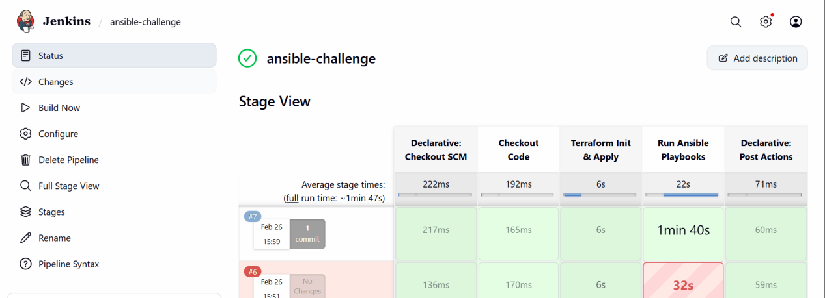

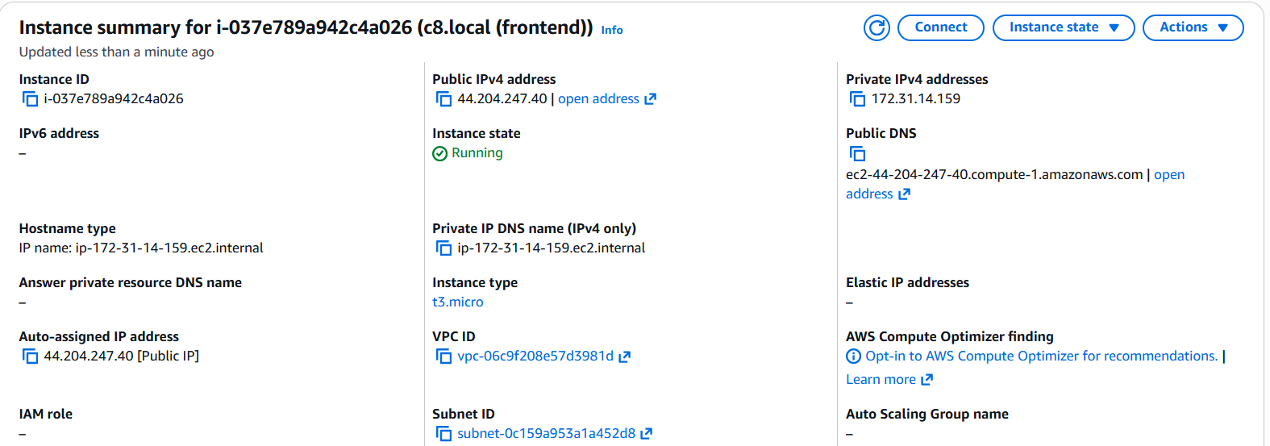

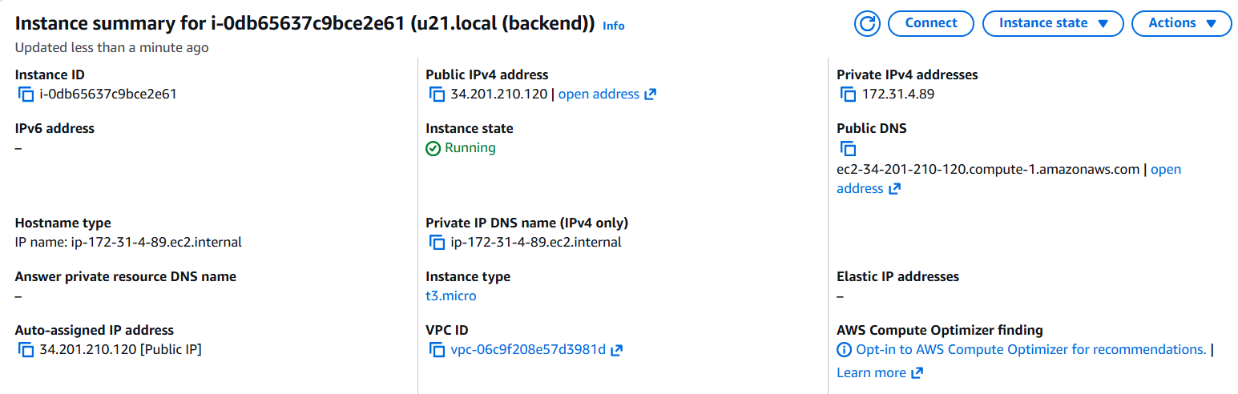

2. Backend (Ubuntu)
sudo systemctl status netdata
sudo ss -tulpn | grep 19999
- Netdata running on 0.0.0.0:19999

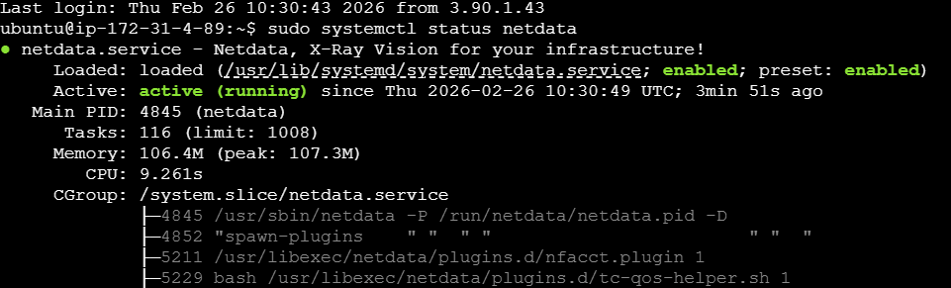
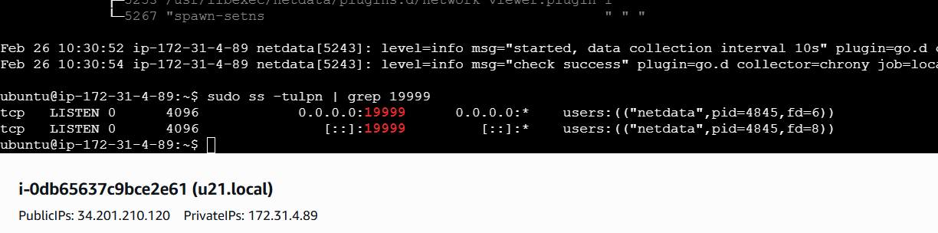

3. Frontend (Amazon Linux)
sudo systemctl status nginx
sudo ss -tulpn | grep 80
Nginx running and listening on port 80

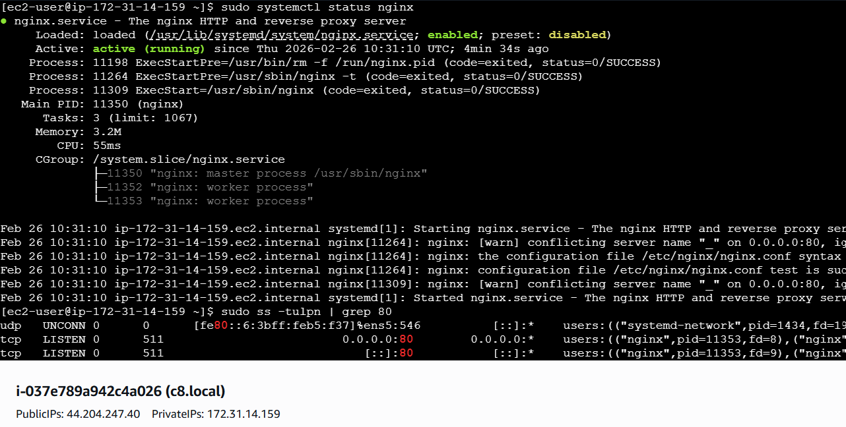
4. Browser Validation
- Direct Netdata:
- http://backend_public_ip:19999
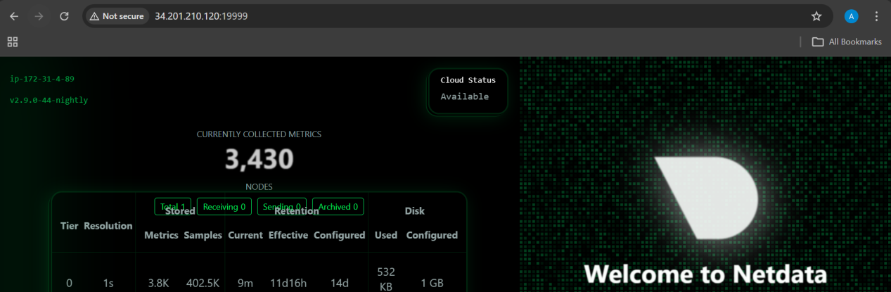
- Via Reverse Proxy:
- http://frontend_public_ip
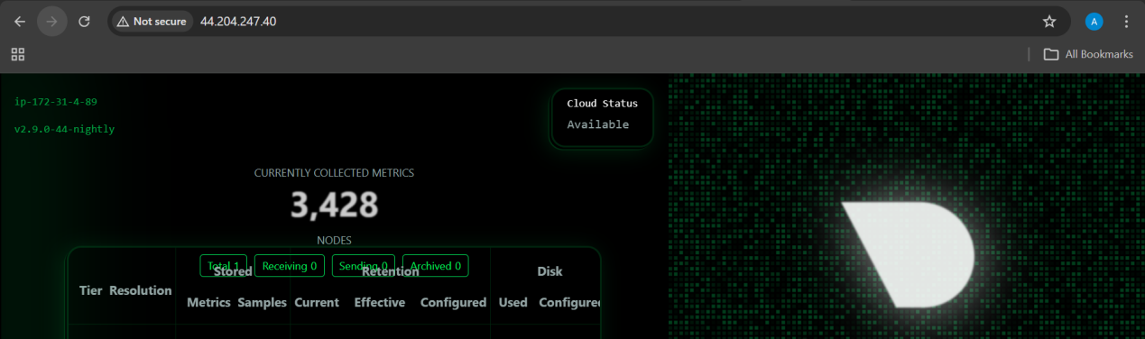
- Netdata dashboard loads successfully in both cases

